# The current situation

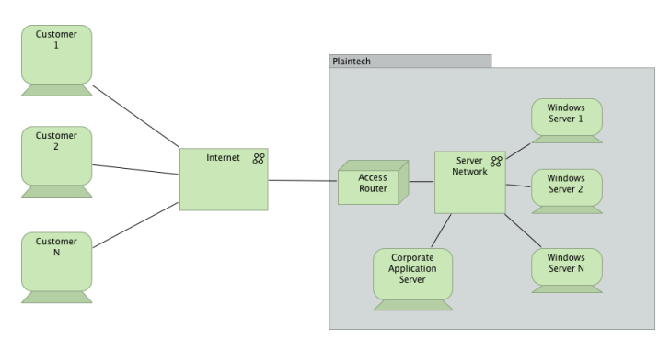At this moment PlanTech is using dedicated hardware to meet the requirements of their customers. An example of the current situation is shown in Figure 1. The first thing to notice is that there is no use of redundancy, separate storage units and backup systems. This means that when something went wrong, in case of fire or system failure, there is no backup or redundancy of the systems. So wen something goes offline it really goes offline and some needs to go to the physical location of the servers/hardware. Another problem is that when a customers order an instance of a system, PlanTech needs to reconfigure the switches and firewalls. But that isn’t all they also need to buy a new system and place that in the existing infrastructure. So the time between buying an instance and getting it online is really high.

Figure 1

# The desired situation

The desired situation is where we use Virtualization systems that are not using dedicated hardware for the virtualizations but virtual hardware. In this way the company can optimize their servers and make use of the entire servers. The storage need to be allocated by a SAN server, so that the hard drive space is scalable for the costumers. Another advantage is that the hard drives are redundant. Because the hard drives are in a RAID configuration (redundant) there will be no chance of data loss.

Not only the hard drives need to be redundant, but the servers and network devices (such as routers, switches, cables, network cards and IP addresses) as well . In this way there is always a service available to make a virtualization for a costumer.

Windows and different distro’s of Linux needs to be supported by the virtualization servers and the customer gets full access to the virtual machine they bought. At last the customer needs to get a management system where they can back-up/restore the virtual machine or reboot it.

For the company there is a report system where they can see an overview of many things like:

* Customers
* Server resources
* Bandwidth of the network
* Virtual machines

Then they has to have a system where they can manage the ports to reduce security issues.